https://www.jdoodle.com/embed/v0/5WrP
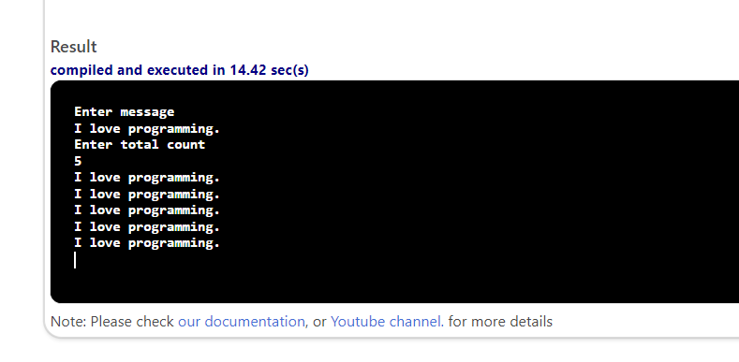

#include <iostream>

using namespace std;

int main()
{
string message;

int count, totalCount;
cout << "Enter message" << endl;
getline (cin, message);
cout << "Enter total count" << endl;
cin >> totalCount;

count = 0;
while (count < totalCount)
{
cout << message << endl;
count++;
}

return 0;
}

